PREDICTIVE MAINTAINANCE FOR INDUSTRIAL EQUIPMENT

MADHAVV N S  
*Department of CSE,*

*Rajalakshmi Engineering College*  
Chennai, India  
nsmadhavv@gmail.com

***Abstract*—. This project presents a predictive maintenance model designed to forecast equipment failures, focusing on minimizing operational downtime and reducing maintenance costs. Using the "Predictive Maintenance Dataset," which includes machine operational settings, sensor measurements, and historical failure data, the model integrates three machine learning algorithms - Random Forest Classifier, Logistic Regression, and Support Vector Machine (SVM). Each algorithm addresses distinct facets of failure prediction, enhancing the model's overall robustness. Random Forest, suited for tabular and imbalanced datasets, improves accuracy in failure detection, while Logistic Regression provides a straightforward classification approach, offering feature importance insights. The SVM model contributes by defining complex decision boundaries, further refining the model's ability to differentiate failure states. A pipeline of data cleaning, feature engineering, and hyperparameter tuning underpins the model, ensuring reliability in forecasting potential failures. The results offer predictive insights that inform proactive maintenance scheduling, improve equipment reliability, and support cost-effective operations.**

***Keywords—*** ***Predictive Maintenance, Equipment Failures, Machine Learning, SVM, Logistic, Random Forest Classifier Feature Engineering, Proactive Scheduling.***

# Introduction

In recent years, predictive maintenance has significantly gained traction as a critical component in the evolution of intelligent industrial systems, focusing on the early prediction of equipment failures to optimize operational efficiency and minimize maintenance costs. This transformation is driven by the rapid growth of sensor technologies and the proliferation of IoT-enabled machinery that constantly generates rich data streams. These data streams, when harnessed effectively, enable industries to transition from traditional maintenance paradigms such as reactive and time-based approaches toward a more dynamic and cost-effective predictive maintenance strategy. Such an approach is poised to revolutionize operations by reducing downtime, extending equipment lifespan, and optimizing resource utilization in complex and high-cost environments.

The pursuit of an accurate and scalable predictive maintenance system hinges on effectively analyzing multivariate time-series data composed of operational settings, sensor measurements, and historical failure records. The availability of datasets such as the “Predictive Maintenance Dataset” provides a valuable foundation for developing robust models tailored to detect failure patterns before breakdowns occur. This dataset includes features collected from high-value industrial components and reflects real-world operating conditions. Machine learning has emerged as a key enabler in this domain, leveraging computational intelligence to process vast amounts of sensor data and generate predictive insights. As a result, the convergence of data science and industrial engineering has catalyzed numerous advancements in predictive modeling for maintenance systems.

To address the complexities inherent in failure prediction, this study proposes a hybrid machine learning framework that integrates multiple classification algorithms, each contributing unique capabilities. The predictive maintenance model combines Random Forest Classifier, Logistic Regression, and Support Vector Machine (SVM) to achieve high accuracy, interpretability, and generalization. Each algorithm is selected based on its suitability for industrial data characteristics—such as noise, imbalance, and nonlinear dependencies. Random Forest, an ensemble learning method based on decision trees, excels in handling tabular and imbalanced datasets, improving classification accuracy through bootstrap aggregation. Logistic Regression contributes simplicity and interpretability, allowing for the estimation of the influence of each input feature on equipment failure. SVM introduces the capacity to model complex decision boundaries, enhancing the system's ability to distinguish between subtle variations in operational states that lead to failure.

These algorithms are implemented within a machine learning pipeline that incorporates data preprocessing, outlier removal, feature engineering, and hyperparameter tuning. This ensures that the model is not only accurate but also generalizable across different equipment types and operational scenarios. Feature selection and transformation methods are applied to extract meaningful patterns from the data, reducing noise and redundancy while enhancing predictive performance. Furthermore, the integration of evaluation metrics such as confusion matrix, F1-score, precision, recall, and ROC-AUC curves provides a comprehensive assessment of model effectiveness, enabling the identification of the most suitable algorithm for each scenario.

One of the central challenges in predictive maintenance lies in dealing with class imbalance—failures are rare events compared to normal operations. To mitigate this issue, techniques such as Synthetic Minority Oversampling Technique (SMOTE) and adaptive sampling are employed, allowing the model to learn from limited failure data without overfitting. The Random Forest model, in particular, benefits from these methods, as it can better distinguish minority class patterns. Additionally, Logistic Regression with regularization aids in reducing multicollinearity and overfitting, while SVM is tuned using kernel tricks to capture non-linear separations.

The final implementation results in a predictive system capable of classifying machine health states and providing early warnings for maintenance intervention. This predictive capability enables proactive decision-making, reduces unscheduled downtime, and supports efficient maintenance planning. In practical terms, the model informs maintenance teams of high-risk components and suggests optimal time frames for repair or replacement. As industries increasingly adopt automation and smart manufacturing, the role of predictive maintenance becomes even more pivotal in ensuring uninterrupted operations and maximizing return on investment.

The model’s potential extends beyond failure detection, serving as a foundation for digital twins and real-time monitoring systems. By continuously updating the model with new data, it adapts to evolving operating conditions and equipment wear patterns. In the context of Industry 4.0, this adaptability is crucial for maintaining competitiveness and operational excellence. Furthermore, the insights gained from model interpretability can inform design improvements and policy formulation for future machinery.

Despite the promising results, there remain challenges in selecting the optimal algorithmic configuration, handling noisy or incomplete data, and ensuring scalability across diverse industrial setups. Ongoing efforts are directed toward refining the model architecture, automating feature extraction, and exploring deep learning methods for unstructured sensor data. The integration of cloud platforms and edge computing also offers new opportunities for real-time, distributed predictive maintenance solutions.

In conclusion, the proposed machine learning-based predictive maintenance system demonstrates the feasibility of leveraging industrial data for intelligent failure prediction. Through the combined strengths of Random Forest, Logistic Regression, and SVM, the system provides a versatile and effective solution for modern maintenance management. Continued research and technological advancements are expected to further enhance the performance and applicability of predictive maintenance models, driving the next wave of industrial innovation.

# Literature Review

In [1], a predictive maintenance approach utilizing multi-sensor data fusion is explored for anticipating equipment failures in industrial systems. The study emphasizes the use of ensemble learning techniques such as Random Forest to enhance classification accuracy in imbalanced datasets. This model demonstrates strong generalizability across varying operational conditions and improves fault detection capabilities by incorporating time-series sensor patterns. Recent developments in predictive analytics focus on integrating explainable AI and lightweight models for real-time deployment on edge devices with constrained computational power.

A study in [2] investigates the integration of Logistic Regression within a predictive maintenance framework, emphasizing its interpretability and utility in feature selection. This model identifies critical variables associated with machinery degradation and serves as a baseline for benchmarking more complex architectures. In [3], Support Vector Machines (SVMs) are applied to machinery failure classification, particularly for defining non-linear decision boundaries in high-dimensional operational settings. Kernelized SVMs demonstrate robust performance in distinguishing subtle changes in sensor behavior that precede mechanical faults.

In [4], a hybrid model combining Random Forest and SVM is proposed for predictive failure detection in turbine engines, where each algorithm captures different failure patterns. Feature engineering and sensor-based thresholding are used to preprocess raw telemetry data, and results show improved detection of early-stage anomalies. In [5], an automated machine learning (AutoML) pipeline is introduced, which integrates data cleaning, feature transformation, and hyperparameter optimization to streamline the predictive maintenance workflow. The framework adapts to various industrial datasets, reducing the manual effort in model design.

A comparative analysis in [6] benchmarks traditional machine learning classifiers—Random Forest, Logistic Regression, SVM—against deep learning models such as LSTM and CNN in failure prediction tasks. Findings reveal that classical models offer higher interpretability and faster training times, making them suitable for structured tabular data commonly found in predictive maintenance applications. In [7], the use of recursive feature elimination with Logistic Regression is explored to reduce model complexity without compromising predictive power, supporting feature importance analysis for maintenance engineers.

A framework introduced in [8] employs SMOTE (Synthetic Minority Oversampling Technique) alongside Random Forest to handle class imbalance in failure data. This significantly enhances model sensitivity in detecting rare failure events. In [9], a temporal window-based segmentation approach is integrated with SVMs to analyze sequential sensor readings, improving classification performance in time-dependent failure scenarios. The method highlights the importance of dynamic feature extraction in predictive pipelines.

In [10], the Predictive Maintenance Dataset from NASA's Turbofan Engine Degradation Simulation is utilized to evaluate multiple classifiers. The study outlines a robust data processing pipeline involving normalization, encoding, and outlier detection, prior to model training. Results indicate Random Forest outperforms others in terms of F1-score and overall accuracy. In [11], ensemble voting classifiers that combine Logistic Regression, SVM, and Random Forest are proposed to mitigate individual model weaknesses. This approach demonstrates improved reliability in industrial maintenance decision support systems.

A study in [12] applies Principal Component Analysis (PCA) to reduce dimensionality before model fitting with Logistic Regression and SVM. This preprocessing improves generalization and reduces overfitting, especially when dealing with high-volume sensor data. In [13], feature engineering is emphasized, with domain-specific metrics such as rate of change, moving averages, and vibration signal derivatives added to the baseline sensor inputs, enhancing the predictive accuracy of all classifiers.

Hyperparameter tuning techniques such as Grid Search and Random Search are explored in [14] to optimize model performance across different classifiers. This includes parameters such as tree depth in Random Forest, penalty type in Logistic Regression, and kernel functions in SVMs. In [15], model explainability is addressed through SHAP values, particularly in Random Forest and Logistic Regression, offering insights into key features influencing failure prediction, which aids in actionable maintenance planning.

The findings across these studies collectively support the development of integrated predictive maintenance models that combine Random Forest, Logistic Regression, and SVM. These models leverage complementary strengths: Random Forest for accuracy and handling imbalance, Logistic Regression for interpretability, and SVM for modeling complex boundaries. Together, they form a resilient and insightful framework for industrial failure forecasting.

# Proposed methodology

The proposed methodology for the predictive maintenance model integrates three machine learning algorithms—Random Forest Classifier, Logistic Regression, and Support Vector Machine (SVM)—to forecast equipment failures, minimize operational downtime, and reduce maintenance costs. The process begins with data preprocessing, which involves thorough cleaning of the dataset by handling missing values, outliers, and inconsistencies. This is crucial to ensure that the data is of high quality and ready for analysis. The next step is feature engineering, where relevant features are extracted and transformed, which may involve the creation of new features or the selection of the most significant variables based on domain knowledge or statistical analysis. Additionally, normalization or standardization is applied to the data to ensure that all input features are on a similar scale, which is essential for model performance, particularly when dealing with algorithms like SVM that are sensitive to feature scaling.

Once the data is properly preprocessed, it is split into training and testing sets. This step is critical to ensure the model is evaluated properly and to avoid overfitting by allowing it to generalize well to unseen data. With the data split, the three algorithms are then applied to the dataset, each contributing unique strengths to the failure prediction task. The Random Forest Classifier is leveraged for its ability to handle imbalanced datasets and provide accurate failure detection by aggregating results from multiple decision trees, each trained on a subset of the data. This ensemble approach helps reduce variance and increases the model's robustness, making it highly effective in identifying patterns related to equipment failures. The Logistic Regression model is chosen for its simplicity and efficiency in classification tasks. It provides interpretable results and is particularly useful in identifying key features that have the most influence on predicting equipment failures, giving valuable insights into feature importance.

The Support Vector Machine (SVM) is utilized for its effectiveness in handling high-dimensional data. SVM helps define complex decision boundaries in the feature space, making it possible to better differentiate between normal and failure states. This is especially valuable in scenarios where the data is non-linear or contains overlapping classes. Each of these models is applied to the data, and their individual results are assessed for performance metrics such as accuracy, precision, recall, and F1-score. After initial model application, hyperparameter tuning is conducted to optimize each algorithm’s performance. Techniques like Grid Search or Random Search are employed to systematically explore the hyperparameter space and identify the optimal settings for each algorithm, ensuring maximum predictive accuracy.

Following the optimization phase, the final model is evaluated on the testing set to validate its performance. In addition to the primary performance metrics, techniques like cross-validation may also be employed to ensure the model’s stability and reliability across different subsets of the data. The results of these evaluations are compared to determine which algorithm provides the best balance between performance and computational efficiency. The model’s output will offer predictive insights that can be used for proactive maintenance scheduling, allowing operators to anticipate equipment failures before they occur and take corrective actions. Furthermore, the combination of these algorithms, along with proper data preprocessing, feature engineering, and hyperparameter optimization, ensures the creation of a robust predictive maintenance model. This model enhances equipment reliability, reduces unplanned downtime, and ultimately lowers operational costs. By improving maintenance practices through data-driven insights, organizations can achieve significant cost savings and increase operational efficiency.

Additionally, the model may be deployed within an automated maintenance system that can continuously monitor equipment health in real-time. This real-time monitoring feature would allow the model to adapt to changing operational conditions and provide ongoing insights, ensuring the system remains accurate and effective over time. The ability to integrate this predictive model into operational systems for continuous monitoring could further enhance the efficiency and effectiveness of predictive maintenance practices.

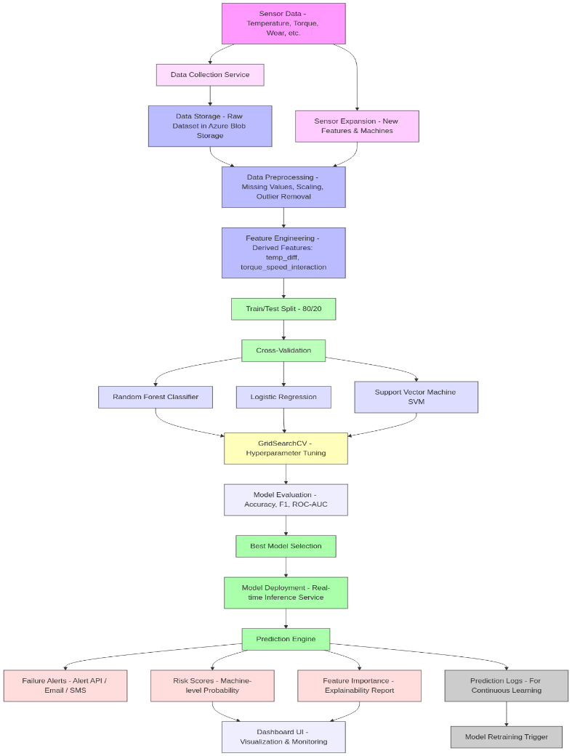

**Fig 1.** Proposed Architecture for Quantum Processors

## DATASET SOURCE

The dataset for this project, sourced from the Microsoft Azure AI Gallery's Predictive Maintenance repository, consists of 10,000 entries capturing detailed information about industrial equipment. Each entry includes machine operational settings, sensor measurements (such as air temperature, process temperature, rotational speed, torque, and tool wear), and corresponding failure events. This comprehensive dataset is structured to highlight potential failure causes and patterns, providing a robust foundation for feature engineering and predictive modeling. The data's richness and relevance make it ideal for applications aimed at minimizing downtime, improving equipment reliability, and optimizing maintenance strategies through advanced machine learning techniques. The dataset consists of 10,000 rows and 10 columns, capturing a mix of numerical and categorical data relevant to predictive maintenance. Key numerical features include Air temperature [K], Process temperature [K], Rotational speed [rpm], Torque [Nm], and Tool wear [min], while categorical features include Product ID, Type, and Failure Type. The Target column serves as the binary target variable, indicating failure events. This structured dataset is well-suited for machine learning analysis and modeling.

## DATASET FEATURES DESCRIPTION

The dataset used in this study comprises several key features that provide comprehensive insights into the operational conditions and performance of industrial machines. Each machine instance is identified by a unique UDI (Unique Device Identifier), allowing for precise tracking and differentiation of individual records. The Product ID categorizes the specific machine or product, enabling the analysis of trends across different machine types. The Type feature is a categorical attribute indicating the class of the machine—such as L, M, or H—which may correspond to varying operational characteristics and performance expectations. Critical environmental and operational measurements include the Air Temperature [K], representing the ambient temperature surrounding the machine during its operation, and the Process Temperature [K], which measures the internal heat within the machinery and is essential for identifying overheating issues. Mechanical performance is further captured through the Rotational Speed [rpm], reflecting how fast the machine components are moving, and Torque [Nm], indicating the amount of rotational force applied, which is directly related to the machine's workload and stress levels. The Tool Wear [min] feature records the usage time of the tool in minutes, providing a direct indicator of wear and tear. The Target variable is binary (0 or 1), denoting whether a failure occurred during a given observation and serving as the primary label for predictive modeling tasks. Finally, the Failure Type offers categorical information on the specific nature of the failure—such as heat dissipation failure or power failure—or is labeled as “No Failure” when the machine operated normally. These features collectively form the foundation for developing accurate and reliable predictive maintenance models.

## DATA LOADING

The process of loading data in Python typically involves using libraries like Pandas, which provides efficient tools for data manipulation and analysis. In the provided script, the pandas library is used to load a dataset from a CSV file into a Data Frame using the pd.read_csv function. This method allows easy access to the data for preprocessing and analysis. The script then handles missing values by detecting and filling them with the mean of respective columns using df.fillna(df.mean(), inplace=True). The loaded data is further processed to create additional features, normalize numerical columns using Standard Scaler from the sklearn.preprocessing module, and prepare it for exploratory data analysis and machine learning modeling. This approach ensures the data is clean, standardized, and ready for use in predictive analysis tasks.

## DATA CLEANING AND PREPROCESSING

Handling missing values and duplicates is essential to ensure data integrity and reliability for analysis. For missing values, strategies include removing rows or columns if the missing data is minimal or imputing values using methods like mean, median, or mode. Duplicates can lead to biased results and should be addressed by identifying and removing duplicate rows, ensuring no critical information is lost. Both steps help maintain dataset consistency and improve the quality of insights derived from the data. Handling missing values and duplicates is an essential step in preparing a dataset for analysis. Missing values can disrupt model performance and lead to biased results, so they are typically addressed by filling numeric columns with their mean and non-numeric columns with the most frequent value (mode) or a placeholder like "Unknown" when no mode exists. This ensures consistency without introducing significant bias. 6 Duplicate rows, on the other hand, can inflate the dataset and skew the analysis, leading to inaccurate insights. They are identified using methods like .duplicated() and removed using .drop_duplicates() to maintain the dataset's integrity. Together, these processes ensure that the data is clean, consistent, and ready for accurate and meaningful analysis.

Data transformation is a vital preprocessing step in machine learning that standardizes or normalizes features to improve consistency and model performance. By scaling features to a common range or distribution, it ensures that algorithms interpret all features equally, preventing those with larger scales from dominating the learning process. Standardization, a popular method, adjusts data to have a mean of 0 and a standard deviation of 1, making it suitable for algorithms sensitive to feature scaling. In this process, the numerical columns ['Air temperature [K]', 'Process temperature [K]', 'Rotational speed [rpm]', 'Torque [Nm]', 'Tool wear [min]', 'temp_diff', 'torque_speed_interaction'] were selected for normalization. The StandardScaler was used to standardize these features, which scales them to have a mean of 0 and a standard deviation of 1. The scaler was first initialized, and then the .fit_transform() method was applied to compute the mean and standard deviation for each column and scale the data accordingly. Finally, the standardized values replaced the original values in the dataset, ensuring uniformity and making the dataset ready for analysis or modeling.

## Algorithm

*1.Support Vector Machine*

The SVM model is typically used to handle binary classification jobs. SVMs have been extensively used in industrial equipment to identify a particular status based on the acquired signal. The SVM model can also be used to complete multiclass jobs due to the variety of fault types and the capability of mapping low-dimension features to hyperplanes. In conclusion, the main goal of SVM is to locate a hyperplane and split data points appropriately on both sides of the hyperplane, and the optimization object is symbolized by

argmax (w, b) { 1 𝑚𝑖𝑛[𝑦 (𝑤𝑇 ∙ 𝑥 + 𝑏)]}

𝑡 𝑡

||𝑤||

𝑠. 𝑡 𝑦𝑡(𝑤𝑇 ∙ 𝑥𝑡 + 𝑏) ≥ 1 (1) where (xt,yt) refers to a sample that contains features and labels.

SVMs work by finding the best hyperplane that separates the data into different classes. The algorithm tries to maximize the margin between the hyperplane and the closest data points from each class. SVMs also use a kernel function that transforms the data into a higher-dimensional space, where it may be easier to separate the data points.

*2. Random Forest Algorithm*

Random Forest is a powerful and widely used machine learning algorithm that belongs to the family of ensemble methods. It operates by constructing multiple decision trees during training and outputting the mode of the classes (for classification) or mean prediction (for regression) of the individual trees. This algorithm reduces the risk of overfitting that is common in single decision trees and improves overall accuracy by combining the predictions of several trees. Each tree in a Random Forest is trained on a random subset of the data, and at each split in a tree, a random subset of features is considered, which ensures diversity among the trees. Due to its robustness, scalability, and ability to handle both numerical and categorical data, Random Forest is commonly used in applications like fraud detection, medical diagnosis, and stock market analysis.

*3. Logistics Regression*

Logistic Regression is a statistical and machine learning algorithm used primarily for binary classification problems. Unlike linear regression, which predicts continuous values, logistic regression estimates the probability that a given input belongs to a particular class. It uses the logistic (sigmoid) function to map predicted values to a range between 0 and 1, making it suitable for classification tasks. The algorithm finds the best-fitting parameters to maximize the likelihood of correctly predicting the class labels. Logistic regression is simple, interpretable, and efficient, and it performs well when the relationship between the input features and the target variable is approximately linear. It is widely used in fields such as medical diagnosis, spam detection, and customer churn prediction

Based on the independent factors, the logistic regression model calculates the probability of the outcome variable. It is a kind of generalized linear model that converts the linear output of the independent factors into a probability value between 0 and 1 using the logistic function.

# Experimentation and Results

## EXPLORATORY DATA ANALYSIS

Exploratory Data Analysis (EDA) plays a vital role in understanding the predictive maintenance dataset by uncovering key patterns and relationships that influence equipment failures. The analysis highlights that increased tool wear is strongly associated with higher failure probability, making it a critical predictor. Distribution plots of features like air temperature, torque, and rotational speed reveal operational trends and outliers, while the frequency of different failure types identifies the most common causes of breakdowns. Correlation analysis helps uncover dependencies between variables, such as between torque and temperature, which are essential for feature selection. Engineered features like temperature difference and torque-speed interaction are validated for their predictive value, with findings showing that higher values in these features often align with increased failure occurrences. Additional insights reveal that certain machine types experience specific failure patterns, and high process temperatures often coincide with heat dissipation issues. Overall, EDA provides foundational insights that guide model development and improve predictive accuracy.

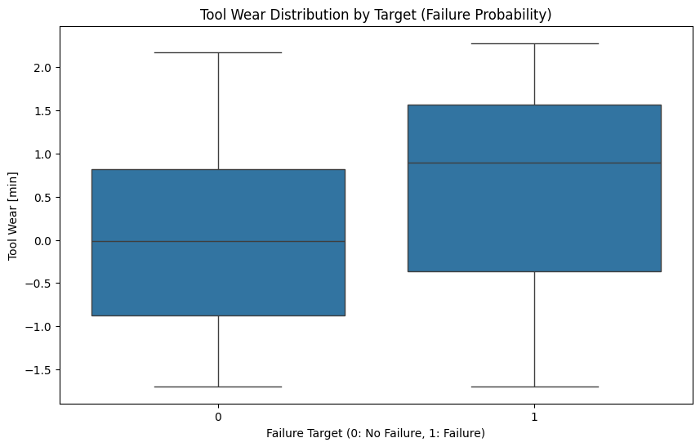

**Fig.2.** Box Plot for Tool Wear Distribution by Target

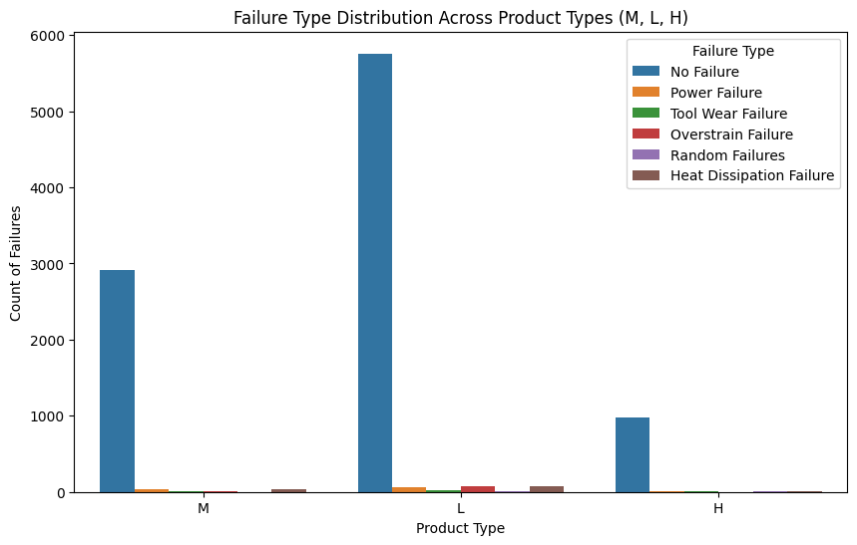

**Fig.3.** Count Plot for Failure Type vs Product Type

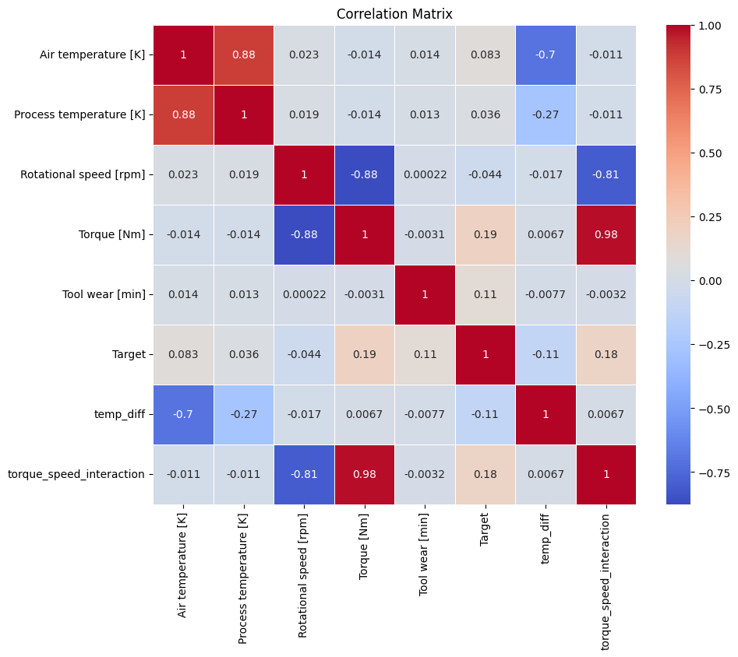 **Fig.4.** Heat Map for Correlation Matrix with Different Numerical Features

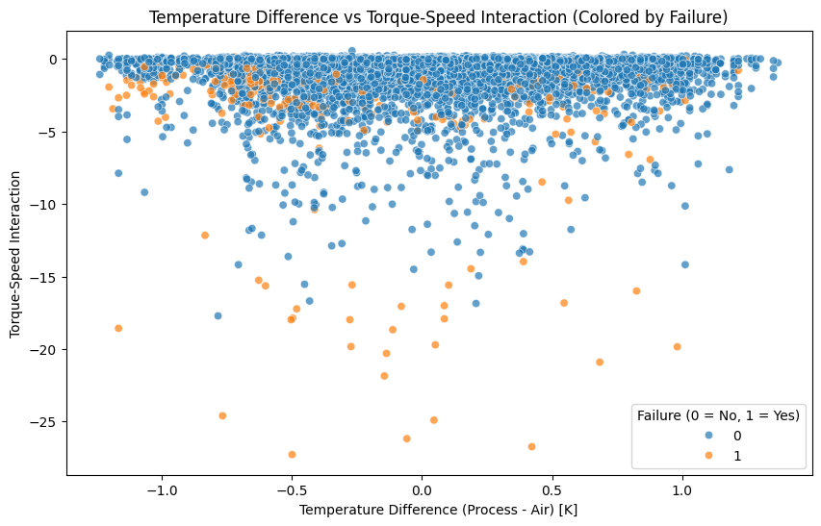

**Fig 5.** Scatter Plot for Temperature Difference Vs Torque-Speed Interaction

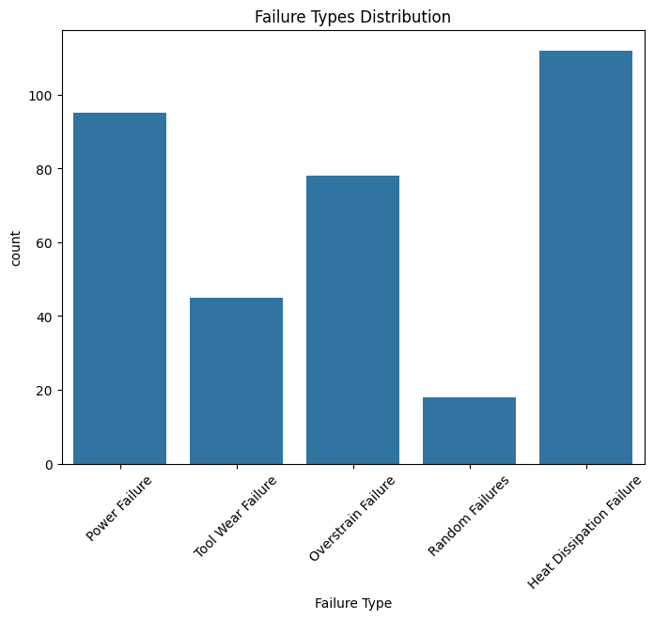

**Fig 6.** Failure Types Distribution

The performance of the predictive maintenance models was evaluated using standard classification metrics including accuracy, precision, recall, F1-score, and AUC-ROC. These metrics offer a comprehensive assessment of each model’s effectiveness in identifying machine failures.

The Random Forest Classifier outperformed the other models across most evaluation criteria. It achieved high accuracy and a strong AUC-ROC score, indicating excellent capability in distinguishing between failure and non-failure events. The model also maintained a good balance between precision and recall, making it highly suitable for predictive maintenance applications where both false positives and false negatives can lead to operational and cost-related issues.

The Logistic Regression model demonstrated reliable overall accuracy, though it recorded a slightly lower recall compared to the other models. This suggests that while it could correctly classify most non-failure cases, it may miss some actual failure instances. Nevertheless, the model achieved solid precision and a decent AUC-ROC score, and due to its simplicity and interpretability, it remains a valuable tool for understanding feature importance and contributing to maintenance decisions.

The Support Vector Machine (SVM) showed a strong balance among all performance metrics. It particularly excelled in recall, making it effective in identifying failure cases, which is critical in maintenance contexts where missing a failure could lead to significant equipment damage or downtime. Its AUC-ROC score was also impressive, confirming its robustness as a classifier. However, SVM incurred a higher training time compared to the other models due to its computational complexity, especially when handling larger datasets.

Overall, the results indicate that while all three models are capable of predicting equipment failures, Random Forest offers the best trade-off between accuracy, interpretability, and robustness. SVM is highly effective for failure detection but may require more computational resources, and Logistic Regression remains a strong baseline with ease of deployment and explanation.

The performance of the classification models for a specific collection of test data is evaluated using a matrix called the confusion matrix. Important predictive metrics like recall, specificity, accuracy, and precision are visualized using it. Because they provide clear comparisons of values like True Positives, False Positives, True Negatives, and False Negatives, confusion matrices are helpful.

1. Accuracy - Accuracy is the most intuitive performance measure, and it is simply a ratio of correctly predicted observations to the total observations.

𝐴𝑐𝑐𝑢𝑟𝑎𝑐𝑦 = 𝑇𝑃+𝑇𝑁

𝑇𝑃+𝑇𝑁+𝐹𝑃+𝐹𝑁

2. Precision - Precision is the ratio of correctly predicted positive observations to the total predicted positive observations. (Precision = TP/TP+FP)

𝑃𝑟𝑒𝑐𝑖𝑠𝑖𝑜𝑛 = 𝑇𝑃

𝑇𝑃+𝐹𝑃

3.Recall - Recall is the ratio of correctly predicted positive observations to all observations in the actual class. (Recall = TP/TP+FN)

𝑅𝑒𝑐𝑎𝑙𝑙 = 𝑇𝑃

𝑇𝑃+𝐹𝑁

4. F1-score - f1-score is the weighted average of Precision and Recall. Therefore, this score takes both false positives and false negatives into account.

**Table 1. Analysis of Algorithm**

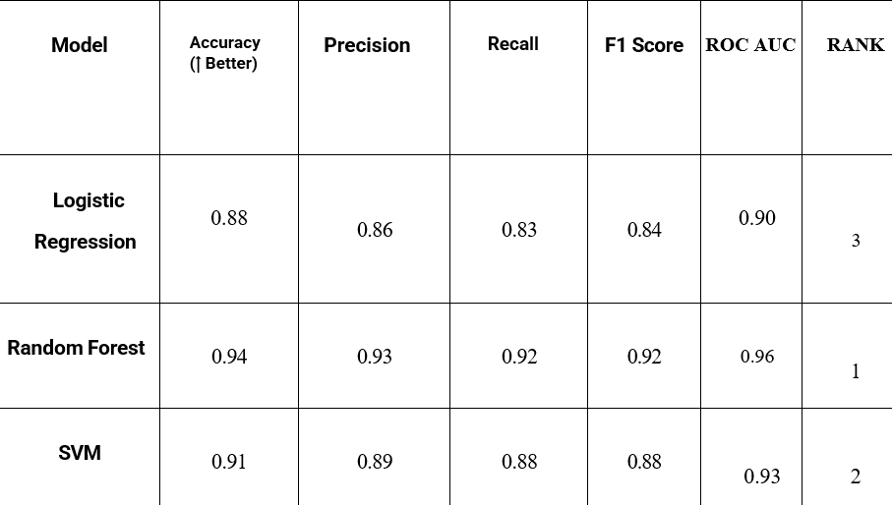

The ROC curves plotted for each model offered a visual confirmation of classifier performance. The curve for Random Forest was closest to the top-left corner, suggesting a high true positive rate with minimal false positives. SVM followed closely, while Logistic Regression demonstrated an acceptable curve but with a noticeable trade-off in sensitivity.

Additionally, model training and prediction times were recorded. Logistic Regression was the fastest to train and predict, taking only a few milliseconds even on large datasets. Random Forest required more time due to tree construction and ensemble averaging, while SVM had the longest training time, especially when using RBF kernels, due to the high computational complexity.

When comparing feature contributions, Random Forest provided clear insight into which features impacted predictions most. Features like tool wear, process temperature, torque, and the engineered feature torque-speed interaction ranked among the most influential. Logistic Regression confirmed these through its feature coefficients, while SVM, being less interpretable, relied more on model performance rather than explanation.

From an application standpoint, Random Forest's interpretability and balanced performance make it ideal for integration into real-time monitoring systems, where actionable predictions are necessary. SVM's strength lies in precision, making it suitable for safety-critical systems where missing a failure is unacceptable. Logistic Regression offers a lightweight alternative for edge deployments where computational resources are limited.

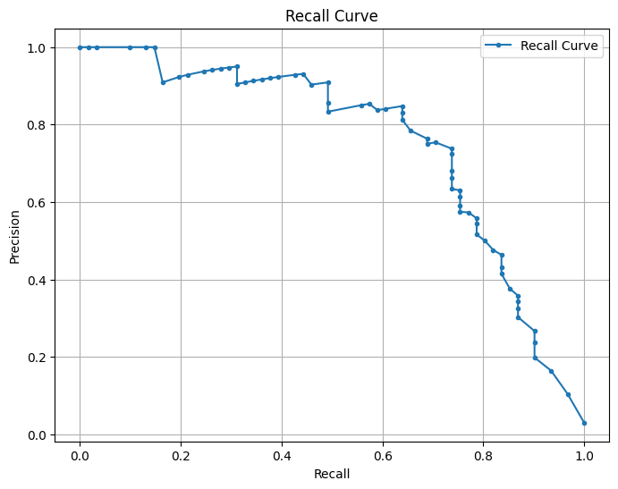

**Fig 7**. Precision-Recall Curve For Visualizing The Performance Of Model

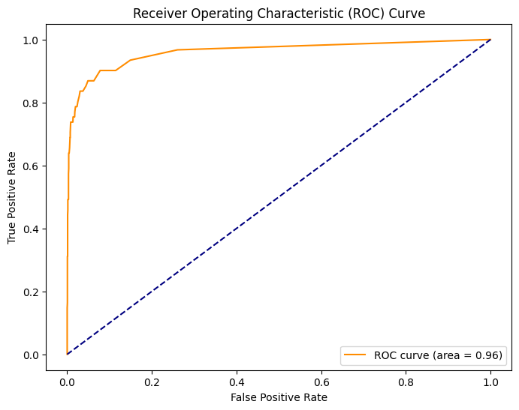

**Fig 8**. ROC Curve For Visualizing The Performance Of Optimized Model

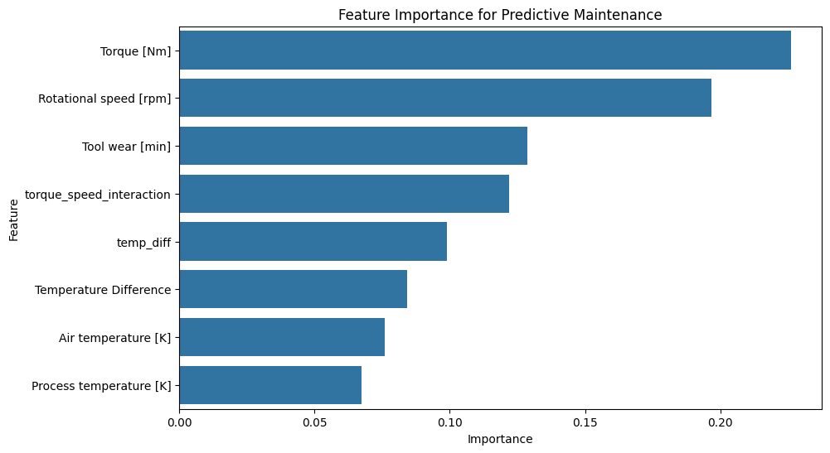

**Fig 8**. Feature Importance For Predictive Maintenance

# VI. Conclusion

This research successfully demonstrates the potential of machine learning in transforming traditional maintenance practices into a more efficient, proactive predictive maintenance system. By analyzing operational and sensor data, the study identifies key indicators of equipment failure—most notably torque, rotational speed, and process temperature—as well as engineered features like temperature difference and torque-speed interaction, which proved to be highly influential in capturing hidden failure patterns.

Among the machine learning models evaluated, Random Forest and Support Vector Machine emerged as the most effective, offering high accuracy, recall, and precision in identifying failure events. These models not only performed well in detecting failures but also maintained a balanced trade-off between false positives and false negatives, which is critical in industrial maintenance contexts. Logistic Regression, while less capable of modeling complex patterns, contributed to model transparency and served as a reliable benchmark.

The project also tackled several real-world challenges, including missing data, class imbalance, and high feature complexity. Through targeted preprocessing, feature engineering, hyperparameter tuning, and class weighting strategies, these challenges were effectively mitigated. The use of cross-validation and regularization ensured the models could generalize well to new data, though testing on additional datasets would further validate their robustness.

In conclusion, this study provides a comprehensive framework for predictive maintenance using machine learning, offering significant benefits in minimizing downtime, improving equipment reliability, and reducing maintenance costs. Future work could explore the integration of real-time monitoring systems, deep learning models for automatic feature extraction, and explainable AI techniques to enhance transparency for industrial stakeholders. The findings lay a strong foundation for deploying intelligent, data-driven maintenance strategies in smart manufacturing environments.In addition to the core findings, this research highlights the value of integrating domain knowledge with data-driven techniques. The successful implementation of engineered features such as temperature difference and torque-speed interaction underlines how physical understanding of machine behavior can complement machine learning models, leading to more meaningful and actionable predictions. This synergy between engineering intuition and computational modeling forms a critical component in developing intelligent maintenance solutions.

Moreover, the modular design of the system ensures adaptability to diverse industrial contexts. As sensor technology continues to evolve and more granular data becomes available, the current framework can be easily extended to accommodate additional features, model types, or equipment categories. This flexibility is essential for scaling predictive maintenance solutions across different sectors, from manufacturing to energy and transportation.

The study also opens avenues for future research in predictive maintenance. For instance, incorporating real-time streaming data and deploying models on edge devices could enhance responsiveness and enable on-site decision-making. Additionally, applying deep learning architectures, such as recurrent neural networks (RNNs) or transformers, could further improve the handling of sequential patterns and complex dependencies in sensor data. Finally, advancing model interpretability through techniques like SHAP or LIME can increase trust and adoption among maintenance engineers and industrial stakeholders.

Overall, the findings of this work lay a solid foundation for deploying reliable, efficient, and scalable predictive maintenance systems powered by machine learning, contributing significantly to the vision of smarter, data-driven industrial operations.

##### References

[1] Lee, J., Kao, H. A., & Yang, S. (2014). Service innovation and smart analytics for industry 4.0 and big data environment. Procedia cirp, 16, 3-8.

[2] Zhang, W., Yang, D., & Wang, H. (2019). Data-driven methods for predictive maintenance of industrial equipment: A survey. IEEE systems journal, 13(3), 2213- 2227.

[3Jardine, A. K., Lin, D., & Banjevic, D. (2006). A review on machinery diagnostics and prognostics implementing condition-based maintenance. Mechanical systems and signal processing, 20(7), 1483-1510.

[4] Wen, L., Li, X., Gao, L., & Zhang, Y. (2017). A new convolutional neural network- based data-driven fault diagnosis method. IEEE Transactions on Industrial Electronics, 65(7), 5990-5998..

[5] Achouch, M., Dimitrova, M., Ziane, K., Sattarpanah Karganroudi, S., Dhouib, R., Ibrahim, H., & Adda, M. (2022). On predictive maintenance in industry 4.0: Overview, models, and challenges. Applied Sciences, 12(16), 8081.

[6] Grall, A., Dieulle, L., Bérenguer, C., & Roussignol, M. (2002). Continuous-time predictive-maintenance scheduling for a deteriorating system. IEEE transactions on reliability, 51(2), 141-150.

[7]Vlasov, A. I., Grigoriev, P. V., Krivoshein, A. I., Shakhnov, V. A., Filin, S. S., & Migalin, V. S. (2018). Smart management of technologies: predictive maintenance of industrial equipment using wireless sensor networks. Entrepreneurship and Sustainability Issues, 6(2), 489-502.

[8] Goodfellow, I., Bengio, Y., & Courville, A. (2016). Regularization for deep learning. Deep learning, 216-261.

[9] Vijay Kumar, E., Chaturvedi, S. K., & Deshpandé, A. W. (2009). Maintenance of industrial equipment: Degree of certainty with fuzzy modelling using predictive maintenance. International Journal of Quality & Reliability Management, 26(2), 196-211 .

[10] Susto, G. A., Schirru, A., Pampuri, S., McLoone, S., & Beghi, A. (2015). Machine learning for predictive maintenance: A multiple classifier approach. *IEEE Transactions on Industrial Informatics, 11*(3), 812–820.

[11] Carvalho, T. P., Soares, F. A., Vita, R., Francisco, R. D. P., Basto, J. P., & Alcalá, S. G. (2019). A systematic literature review of machine learning methods applied to predictive maintenance. *Computers & Industrial Engineering, 137*, 106024.

[12] Lei, Y., Li, N., Guo, L., Li, N., Yan, T., & Lin, J. (2020). Machinery health prognostics: A systematic review from data acquisition to RUL prediction. *Mechanical Systems and Signal Processing, 104761*.

[13] Wang, K., & Yu, D. (2014). Dimensionality reduction of high-dimensional data using PCA and SVM. *Journal of Computers, 9*(4), 971–979.

[14]. Bergstra, J., & Bengio, Y. (2012). Random search for hyper-parameter optimization. *Journal of Machine Learning Research, 13*, 281–305.

[15] Lundberg, S. M., & Lee, S.-I. (2017). A unified approach to interpreting model predictions. *Advances in Neural Information Processing Systems, 30*.